**DOM (Document Object Model)**

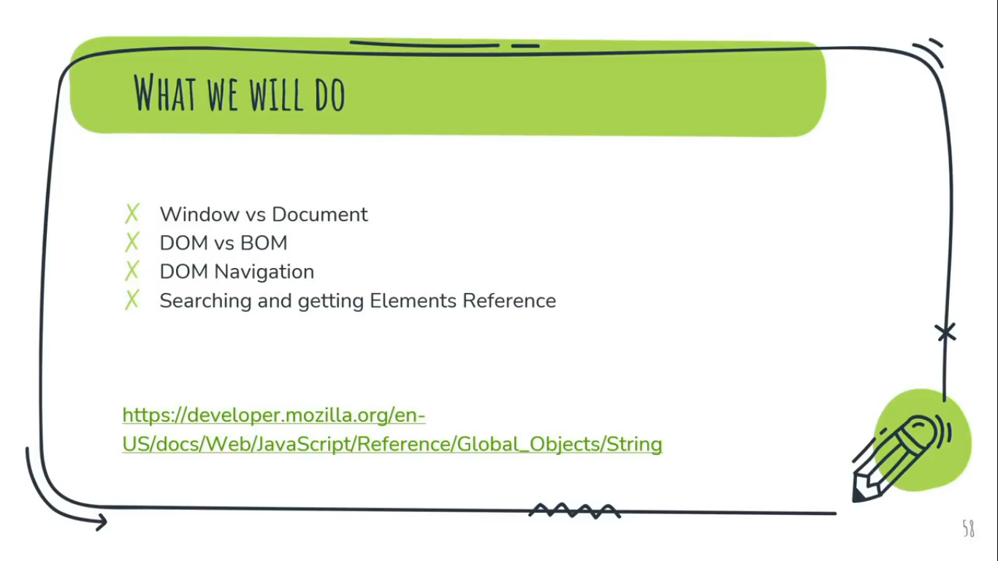

**Window Vs Document**

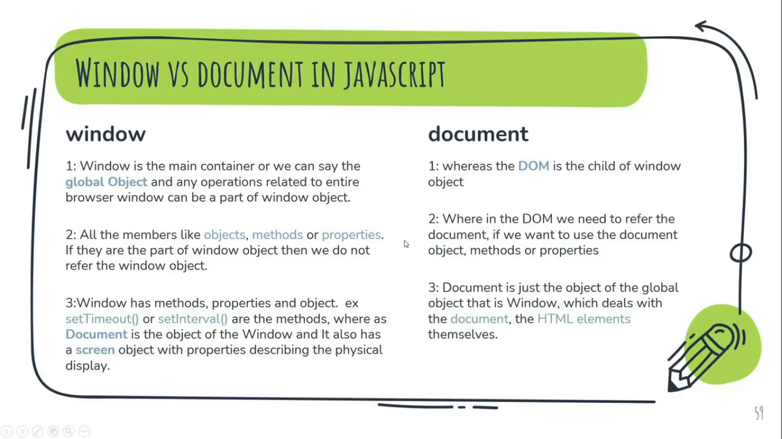

**Window**

1. Window is the main container or we can say, it’s a global Object and any operations need to perform related to entire browser window can be a part of window object.  
   For Ex: the history or to find the url in the tab of browser etc.
2. All the members like objects, methods or properties. If they are the part of window object then we do not refer the window object because it already a global Object, so don’t need to write down window.  
   For Ex:   
   console.log(window.location) or console.log(location) both are same. We don’t need to write window with window object.  
   window.location: gives the current URL  
   *window.document or* just *document*  is the main object of the potentially visible (rendered) document object model/DOM.
3. Window has methods, properties and object. Ex: **setTimeout()** or **setInterval()** are the methods, where as Document is the object of the window and it also has a **screen object** with properties describing the physical display.

**Document**

1. DOM is the child or part of Window Object.
2. Where in the DOM we need to refer the document(i.e. Browser’s Document), if we want to use the document object, methods or properties.  
   For Ex:  
   document.write(location). We have to write document in order to access document object. Or   
   document.getElementById()
3. Document is just the object of the global object that is Window, which deals with, the document, the HTML elements themselves.

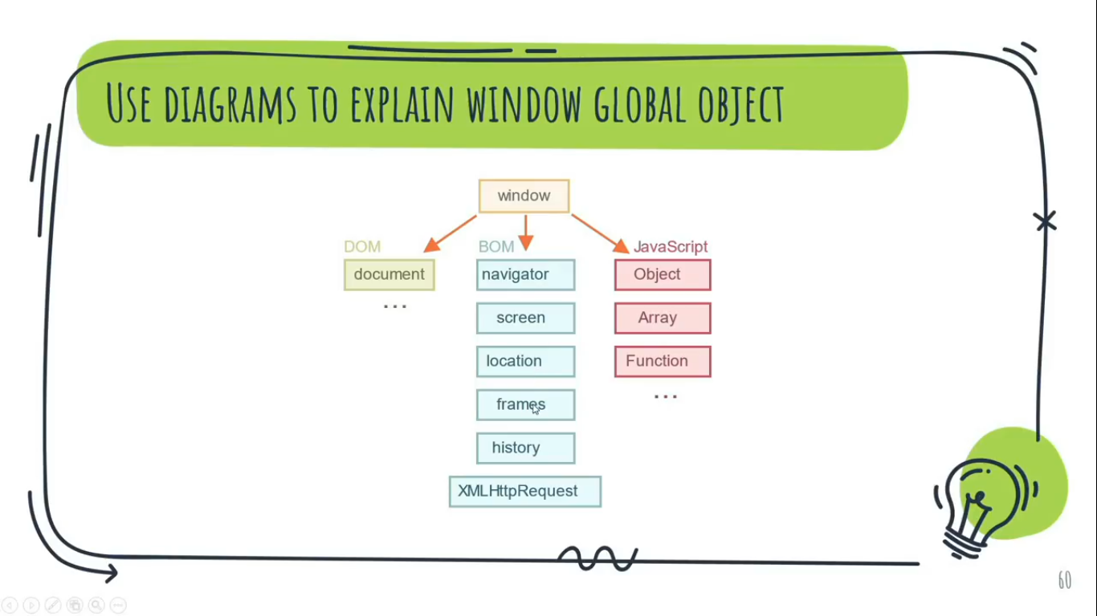

**DOM vs BOM**

**DOM:**The DOM is the Document Object Model, which deals with the document, the HTML elements themselves, e.g. document and all traversal you would do in it, events, etc.

For Example:  
change the background color to red  
document.body.style.background = “red”;

**BOM:**

**BOM** stands for **B**rowser **O**bject **M**odel, which deals with browser components aside from the document, like history, location, navigator and screen (as well as some others that vary by browser). Or  
In simple meaning all the Window operations which comes under BOM are performed using by BOM.

Note:-

* We use BOM only when operations related to Window and use DOM only when operations regarding to HTML.
* Example of window object properties like: innerHeight, innerWidth etc.
* Functions alert/confirm /prompt are also a part of BOM, although they are directly not related to the document, but represent pure browser methods of communicating with the user.  
  Ex:-  
  alert(location.href);

if(confirm("hi")){

location.href="https://www.google.com";

}

* Window.history.back() method use to redirect previous browser page.

**DOM Navigation** (means how DOM is going to help in navigating html elements)

9:00:00 hrs to 9:40:17

**Imp Questions:**

Q1. Can a node in the DOM have multiple parent nodes?  
Ans. No